Write SQL statement for the following
- To find all managers with salary >1500
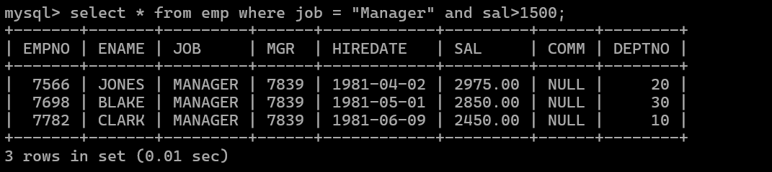
- list all employees with sal >1200 and < 2000
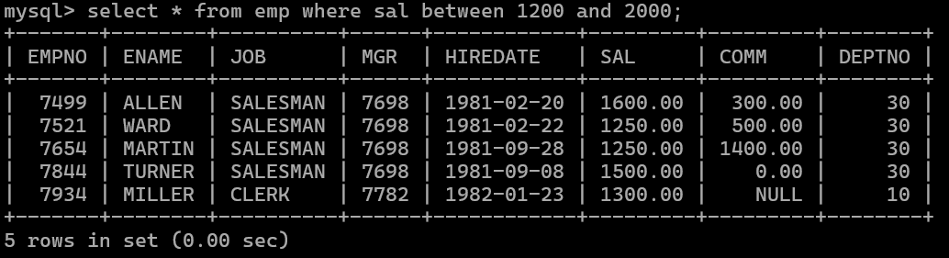
- list all employees with sal is 1600 or sal is 800 or sal is 1900
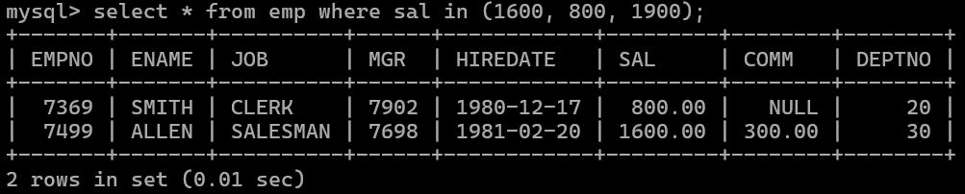
- list all employees with R at second last position in name
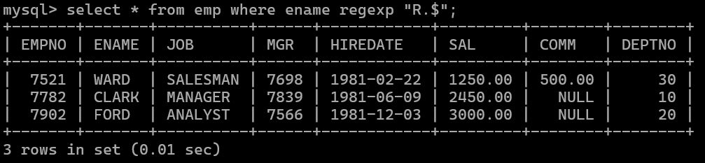

5. List all employees with name starts with A and ends with N
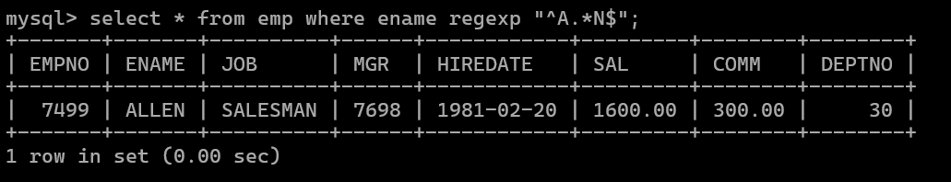

Q2. Solve following
- list all employees with salary > 1250 and dept no=30
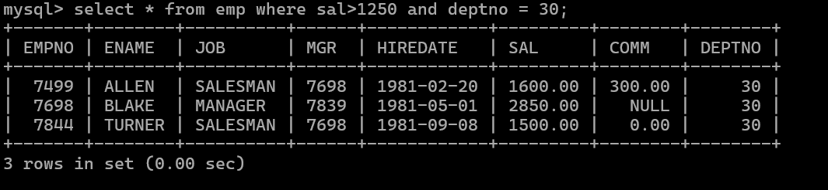

- list all employees with salary >=1250 and <= 3000
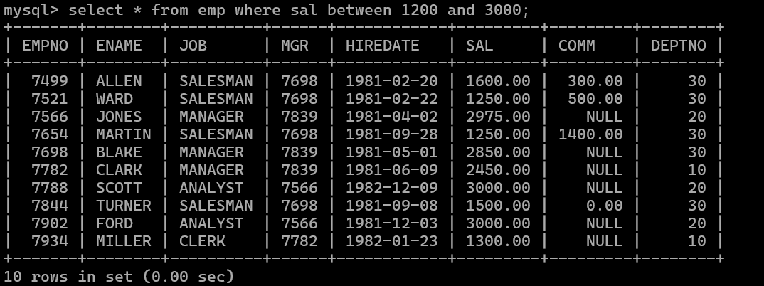

- list all employees with salary >1250 and < 3000
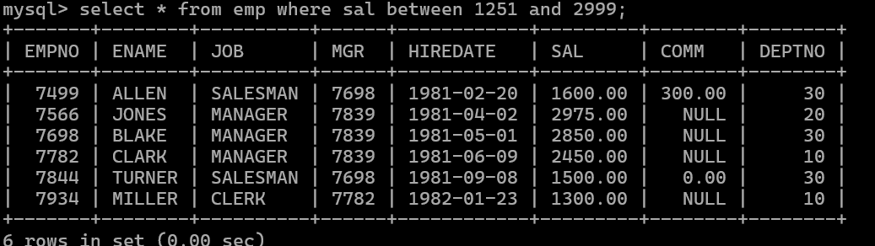

- list all employees with salary either equal to 3000 or 1250 or 2500

- list all employee with name=SMITH
- list all employees with name starting with S
- list all employees with name ending with S
- list all employees with name contains I at 2nd position
- list all employees with name starts with A ends witn N and somewhere in between L is there
- list all employees with name starts with A and B at 3 rd position and P at second last position
- List all employees with name starts with either A or starts with S or starts with W
- find max sal and min sal for each job
- find how many employess have not received commission
- find sum of sal of all employees working in dept no 10
- find maximum salary,average sal for each job in every department
- find max salary for every department if deptno is > 15 and arrange data in deptno order.
- find sum salary for every department if sum is > 3000
- list all department which has minimum 5 employees
- count how many employees earn salary more than 2000 in each job
- list all enames and jobs in small case letter
- list all names and jobs so that the length of name should be 15 if it is samller then add spaces to left
- display min sal,max sal, average sal for all employees working under same manager
- find sum of total earnings(sal+comm), average of sal+comm for all employees who earn sal > 2000 and work in either dept no 10 or 20
- list all employees who joined in Aug 1980 and salary is >1500 and < 2500
- list all employees joined in either aug or may or dec
- display name and hiredate in dd/mm/yy format for all employees whose job is clerk and they earn some commission
- list empcode,empno,name and job for each employee. (note :empcode is 3 to 5 characters from name and last 2 characters of job)
- display thousand separator and $ symbol for commission if it is null then display it as 0 for all employees whose name starts with A and ends with N

- Display empid,name,sal,comm,remark Remark should base on following conditions comm >= 600 "excellent Keep it up"
if it < 600 or not null "good" otherwise "Need improvement"
- Display empid, name, deptno and department name by using following conditions. dept 10 then "Hr"
if 20 then "Admin"
if 30 then "accounts" otherwise purchase

- Practice creating following tables

create table mydept_DBDA (
deptid number primary key,
dname varchar2(20) not null unique, dloc varchar2(20)
)

insert into mydept_DBDA values(30,'Purchase','Mumbai');

create table myemployee (
empno number(5) primary key, fname varchar2(15) not null, mname varchar2(15),
lname varchar2(15) not null,
sal number(9,2) check(sal >=1000), doj date default sysdate, passportnum varchar2(15) unique,

deptno number constraint fk_deptno references mydept_DBDA(deptid) on delete cascade
)

- Create following tables Student, Course
Student (sid,sname) ---------------- sid ---primary key
Course(cid,cname)-------------- cid ---primary key

Marks(studid,coursed,marks) Sample data for marks table studid,courseid,marks
1 | 1 | 99
1 | 3 | 98
2 | 1 | 95
2 | 2 | 97

create table marks( studid number, courseid number, marks number,
constraint pk primary key(studid,courseid),
constraint fk_sid foreign key (studid) references student(sid) on delete set null, constraint fk_cid foreign key (courseid) references course(cid)
)
- Create empty table emp10 with table structure same as emp table. create table emp10 as
(
select * from emp where 1=2;
)

- Solve following using alter table
add primary key constraint on emp,dept,salgrade emp ----→ empno
dept---→ deptno salgrade---→ grade
add foreign key constarint in emp deptno --->> dept(deptno)
add new column in emp table netsal with constraint default 1000

- Update employee sal increase sal of each employee by 15 % sal +comm, change the job
to manager and mgr to 7777 for all employees in deptno 10.
- change job of smith to senior clerk

- increase salary of all employees by 15% if they are earning some commission
- list all employees with sal>smith's sal
- list all employees who are working in smith's department
- list all employees with sal < rajan's sal and salary > revati's sal
- delete all employees working in alan's department
- change salary of Alan to the salary of Miller.
- change salary of all emplees who working in Wall's department to the salary of Miller.
- list all employees with salary > either Smith's salary or alan's sal
- list all employees who earn more than average sal of dept 10
- list all employees who earn more than average sal of Alan's department
- list all employees who are working in purchase department
- list all employees who earn more than average salary of their own department
- list all employees who earn sal < than their managers salary
- list all employees who are earning more than average salary of their job
- display employee name and department
- display empno,name,department name and grade (use emp,dept and salgrade table)
- list all employees number,name, mgrno and manager name
- create following tables and solve following questions(primary keys are marked in yellow) foreign keys are marked in green
product(pid,pname,price,qty,cid,sid)
salesman (sid,sname,address)
category(cid,cnam,descritpion)
  - list all product name,their category name and name of a person, who sold that product
  - list all product name and salesman name for all salesman who stays in pune

  - list all product name and category name

- create following tables and solve following questions(primary keys are marked in yellow) foreign keys are marked in green

faculty(fid,fname,sp.skill1,sp.skill2)
courses(cid,cname,rid,fid)
room(roomid,rname,rloc) faculty
fid fname spskill1 spskill2
- kjzhcjhz a b
- sdd x z
- lksjk a x
- ksdjlkj a b

courses
cid cname rid fid

121 | DBDA 100 10
131 | DAC 101
141 | DTISS
151 | DIOT 105 12

Room
roomid rname rloc

100 | jasmin 1st floor
101 | Rose 2nd floor
105 | Lotus 1st floor
103 | Mogra 1st floor

  - list all courses for which no room is assigned. And all rooms for which are available

  - list all faculties who are not allocated to any course and rooms which are not allocated to any course
  - list all rooms which are allocated or not allocated to any courses

  - list all rooms which are not allocated to any courses
  - display courses and faculty assigned to those courses whose special skill is database
  - display time table --- it should contain course details , faculty and room details
- create following tables with given constraints
product qty >0, default 20.00,pname not null and unique
prodid pname qty price catid sid

123 | lays | 30 | 30.00 | 1 | 12
111 | pepsi | 40 | 50.00 | 4 | 11
134 | nachos | 50 | 50.00 | 1 | 12
124 | dairy milk | 40 | 60.00 | 2 | 14
124 | pringles 40 | 60.00 | 1 14

saleman ----- sname not null
sid sname city
- Rahul Pune
- Kirti Mumbai
- Prasad Nashik
- Arnav Amaravati

category ---- cname unique and not null cid cname description
- chips very crunchy
- chocolate very chocolaty
- snacks yummy
- cold drinks thanda thanda cool cool

- List all products with category chips
- display all products sold by kirti
- display all salesman who do not sold any product
- display all category for which no product is there
- display all products with no category assigned
- list all salesman who stays in city with name starts with P or N
- add new column in salesman table by name credit limit

